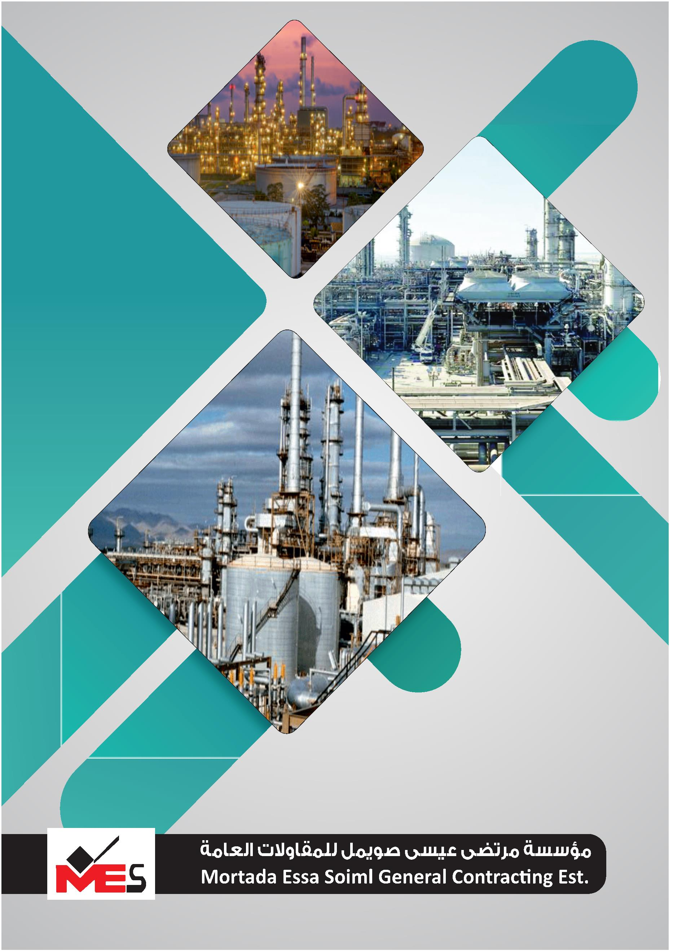

HAMIDUL ISLAM

Operation Manager

MOB : 0543288956

MOB : 0539310709

P.O. BOX : 3779

E-mail: info.mesalarabia@gmail.com

١ ٠ ٠ ٦ ٥ ٢ ٨ ٠

**1**

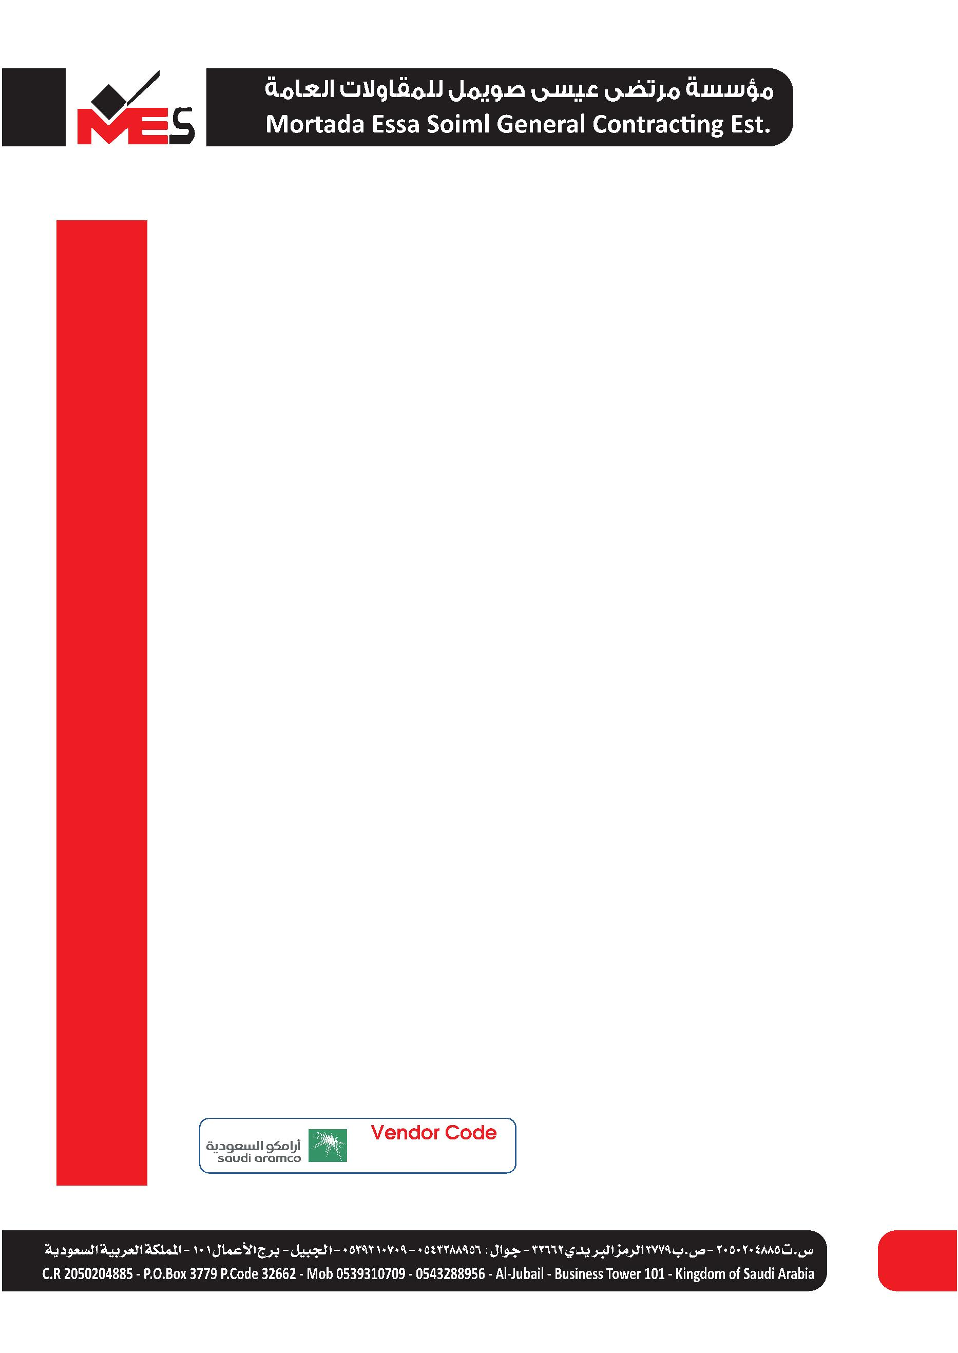

Only two pages were converted.

Please **Sign Up** to convert the full document.

[**www.freepdfconvert.com/membership**](https://www.freepdfconvert.com/membership)

